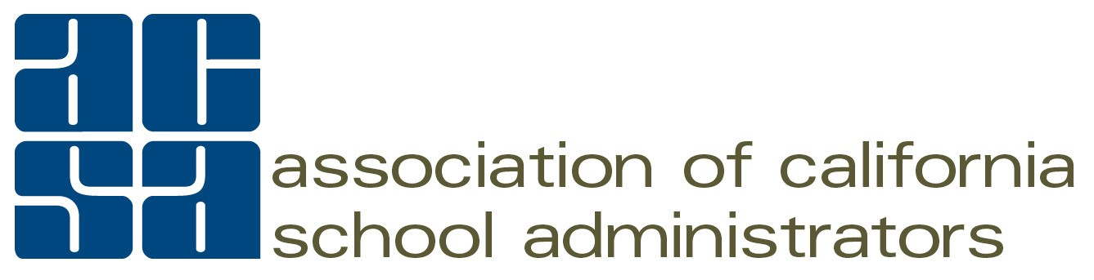

ACSA State Committee & Council
Beginning of the Year Planning Template

ACSA Bylaws and Board-approved Policies & Procedures call for every state committee and council to formulate a plan outlining the group’s purpose, goals, events/activities, and evaluation methods at the beginning of the year for Board consideration. Committee/Council leaders are asked to assure that their group’s work aligns with the group’s purpose and goals articulated in the plan to maximize our collective efforts. Please complete and submit this required Annual Planning Template to Courtney Adams by October 1, 2022.

Today’s Date: Person submitting plan:

This Plan is being submitted on behalf of the following State Committee or Council:

For Councils only: When were the bylaws last reviewed/updated?

Purpose as it appears in Board-Approved Policies:

- In alignment with its Board-Approved Purpose and ACSA’s Strategic Plan, the Committee or Council’s Goals/Objectives for 2022-2023 are as follows:

- The Committee/Council is planning the following specific events, activities, and meetings for 2022-2023:

- Please indicate WHICH Strategic Plan Milestones will be supported by the Committee/Council’s goals/objectives and/or planned events, activities and meetings. The Strategic Plan provides detailed descriptions of each Strategic Issue and Milestone.
KEY RESULT AREA: MEMBER DEVELOPMENT & SUPPORT
- Leadership Development - Milestones A, B, C, D
- Professional Development - Content - Milestones E, F, G
- Professional Development - Delivery/Reinforcement - MIlestones H, I, J
Professional Practice Resources - Milestones K, L
- Member Networking and Collaboration - Milestone M
- District/County/School Site Support Services - Milestones N, O
The Committee/Council will be working on the following milestones in this KEY RESULT AREA:

KEY RESULT AREA: ADVOCACY & INFLUENCE
● ACSA in a Leadership Role - Milestones P, Q, R
● Grassroots Advocacy and Influence - Milestones S, T, U
● Media Relations - Milestones V, W
The Committee/Council will be working on the following milestones in this KEY RESULT AREA:

KEY RESULT AREA: ORG. DEVELOPMENT & SUSTAINABILITY
● Organizational Alignment and Accountability - Milestones X, Y, Z, AA, BB
● Member Outreach and Engagement - Milestones CC, DD, EE, FF
● Member Communication - Milestones GG, HH, II
● Sustainability - Milestones JJ, KK
The Committee/Council will be working on the following milestones in this KEY RESULT AREA:

- What methods will you use to evaluate your success toward accomplishing goals/objectives and supporting the Strategic Plan Milestones?

