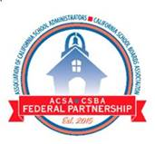

August 29, 2016

Jessica McKinney

U.S. Department of Education

400 Maryland Ave. SW

Room 3W107

Washington, DC 20202-2800

**Re: Notice of Proposed Rulemaking [Docket ID ED-2016-OESE-0053] Title I-Improving the Academic Achievement of the Disadvantaged-Academic Assessments**

Dear Ms. McKinney,

The Association of California School Administrators (ACSA) and California School Boards Association (CSBA) appreciate the opportunity to comment on the proposed regulations regarding the academic assessments required under the Every Student Succeeds Act (ESSA). On behalf of ACSA’s more than 17,000 school leader members and CSBA’s more than 5,000 locally-elected school board members, we are writing to share our comments, with a specific focus on policies that will best meet the needs of California’s diverse education community.

California’s public schools serve 6.2 million students in more than 1,000 school districts that span the spectrum with regard to size, demographics, needs, and other characteristics. Our associations, working as partners with shared federal law and policy priorities, recognize the importance of academic assessments to inform teaching, learning and accountability. Our State’s assessment system plays a central role in California’s new Local Control Funding Formula (LCFF), which heavily weighs student outcomes on assessments and other key measures. Our members support California’s use of the Smarter Balanced Assessments in English language arts/literacy and mathematics, which emphasize interim and summative assessments in support of learning and to inform instruction. Both at the state level and in many of our school districts, work is underway to improve the ways in which we gather and use evidence of student learning to improve instruction and promote equity.

Although we support many of ESSA’s provisions, we would have preferred a framework granting states more flexibility in designing statewide assessment systems that give educators the feedback they need. While this proposed regulation incorporates reasonable requirements that will help us strengthen our systems and practices, we urge you to address the following issues when you publish the regulations in final form:

1. **The Department should encourage the use of alternate forms of assessment.**  While §200.2 permits state assessment systems to rely, in part, on assessments “partially delivered in the form of portfolios, projects, or extended performance tasks,” we urge the Department to seek opportunities to truly promote the use of these alternate forms of assessment so that they serve as better and more widely used options over time. This step could include providing financial or other incentives, such as targeted regulatory relief, to districts willing to innovate.
2. **The Department should not expand on the statutory requirements for providing information to parents.** Sharing assessment information and student results with families is an important aspect of our members’ work. Without timely and effective communication with families, efforts to improve instruction, support student learning, and strengthen schools is hampered. While we support the Section 200.2 requirement that information be provided to families in an understandable and uniform format, and, to the extent practicable, written in a language that parents can understand, we have serious concerns with the proposed requirement that information be orally translated for parents if it is not practicable to provide a written translation. This requirement exceeds the statutory mandate and would create a significant new financial and operational burden for districts throughout our state. In the Los Angeles Unified School District, for example, 92 languages other than English are spoken by students and parents. District and school leaders are taking all reasonable steps to communicate with these parents. In many instances, this includes providing oral translations of school information including student test results. However, any decision to require oral translations, particularly without the commitment of additional funding to provide for them, should be left to state and local leaders.
3. **The Department should shift its focus from states’ demonstration of effort to develop language assessments to the provision of technical and other assistance.** As noted above, California leads the nation in terms of student enrollment in K-12 public schools and the percentage of students participating in programs for English learners (ELs). Our state, district, and school leaders are committed to identifying the specific needs of EL’s and to supporting their learning, including through the use of academic assessments offered in languages other than English. Our students and school leaders need federal assistance in support of our state’s efforts to develop academic assessments for all languages other than English that are present to a significant extent in participating student populations. The related requirements of Section 200.6 seem reasonable as currently defined, yet we know from experience that requirements such as these (e.g., that states provide a description of the process used to gather meaningful input and an explanation of the reasons the state has not been able to complete test development) can lead to a greater focus being placed on compliance than on effective technical assistance and sound investments to actually expand the number of assessments available in other languages for students to use.
4. **The Department should revise the 1 percent waiver process to minimize administrative burden and focus instead on assisting states and districts with efforts to ensure the appropriate, limited use of alternative assessments.** In establishing waiver requirements for a State that anticipates it will exceed the 1 percent cap, the NPRM would have States provide an assurance, at least 90 days prior to the start of the State’s first testing window, that it has verified that each LEA that the State anticipates will significantly contribute to the State’s exceeding the cap has followed the State’s guidelines on the use of alternate assessments. It would further require, on the same timeline, that each State provide a plan and timeline for improving implementation of its guidelines, providing oversight, and more. While we understand the Department’s rationale for seeking to impose these requirements, and are committed to improving the use of alternative assessments, ensuring the appropriate use of accommodations for students with disabilities, and addressing any disproportionality, we are concerned that these waiver criteria are in conflict with the steps Congress took to establish a more thoughtful approach to this challenging issue. The NPRM would require that States undertake a burdensome audit of LEA compliance during the very period in which IEP teams, parents, and school leaders should be focused on making the best decision, on a case by case basis, for students. The waiver requirements should instead require that States develop plans to address any deficiencies in LEA and IEP team processes after the close of the testing window.

We appreciate your careful consideration of our recommendations and would be pleased to work with you and your staff to address them.

Sincerely,

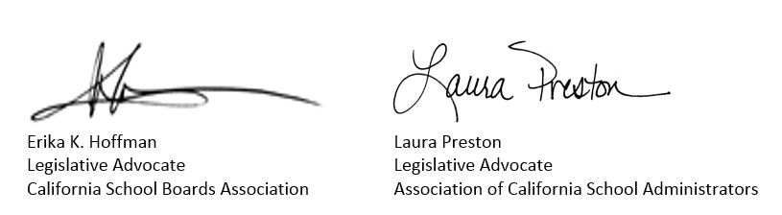

Erika K. Hoffman Laura Preston

Legislative Advocate Legislative Advocate

California School Boards Association Association of California School Administrators

[ehoffman@csba.org](mailto:ehoffman@csba.org) [lpreston@csba.org](mailto:lpreston@csba.org)

916/669-2553 916/444-3216